**Structural Engineering Competition for the Youth**

**Paper Tower Crane Challenge**

**塔吊大作戰: 紙舞穹蒼**

*Co-organized by*

*Structural Division of The Hong Kong Institution of Engineers*

*Department of Civil Engineering, The University of Hong Kong*

*Department of Construction, Environment and Engineering, Technological and Higher Education Institute of Hong Kong*

*Supported by*

*Business – School Partnership Programme, Education Bureau, Hong Kong*

*City University of Hong Kong*

*The Hong Kong Polytechnic University*

*The Hong Kong University of Science and Technology*

**Date: 25 June 2024 (Registration deadline)**

**5 July 2024 (Briefing); 10:00am -11:30am**

**19 July 2024 (Competition); 8:45 am - 5:00 pm**

**Venue: Briefing:**

**Lecture Theatre 5,**

**Technological and Higher Education Institute of Hong Kong (THEi)**

**20A Tsing Yi Road, Tsing Yi**

**Competition:**

**The Tam Wing Fan Innovation Wing, University of Hong Kong**

**Organizing Committee**

|  |  |
| --- | --- |
| Ir Dr Ray Su  Ir Kevin Tang |  |
| Ir Dr Simon Wong  Ir Jesse Chan  Ir Dr Paul Lam  Ir Prof Ben Young  Ir Prof J G Dai |  |

**Target participants**

Secondary school students (Form 4 to Form 5 students only). Each team consists of 4 students. Each secondary school can only form one team for the competition.

**Description of the competition**

The main purpose of this competition is to raise secondary school students’ understanding and interest in structural engineering through the design and build of a paper tower crane subjected to gravity load. Hopefully, this competition can provide students with valuable experience which can facilitate the career planning of students and enrich them the knowledge of engineering industry or the career paths of engineers.

The model competition involves design, fabrication and testing of a **tower crane**. The model shall be assembled / fabricated with A4 papers and adhesive tape as per provided by the organizer.

**Regulations**

The regulations consist of two parts. They are the model requirements and the rules.

**Model Requirements**

1. The design of the tower must be innovative and aesthetic. It should be structurally stable and effective.
2. The tower crane must be made by the materials provided by the organizer.
3. The height of cantilever arm is between 1.0m and 1.5m. It is measured from the top level of cantilever arm to the base of the tower. The total height of tower crane should not exceed 1.8m. The length and width of the base shall not exceed 50cm (A 50cm x 50cm square will be shown on the baseboard). The length of the cantilever arm is between 50cm and 100cm (which is measured from the centreline of the 50cm x 50cm square on the baseboard to the loading point). Tower lies outside these ranges will be disqualified.

The headroom below the cantilever arm shall provide at least 50cm (which is measured from the lowest point of the cantilever arm to the base). The loading point of the cantilever arm should be designed by the students.

1. Loading test will be carried out by adding weight progressively to a hanger (to be provided by the organizer). The structure will be considered as failure if the hanger reaches the ground within 10 seconds after adding weight.
2. The paper tower shall be fixed firmly on the wooden baseboard provided the organizer by adhesive tape as per provided.
3. Each team shall prepare a poster in A4 size to present their design ideas. The poster could be prepared before the competition.

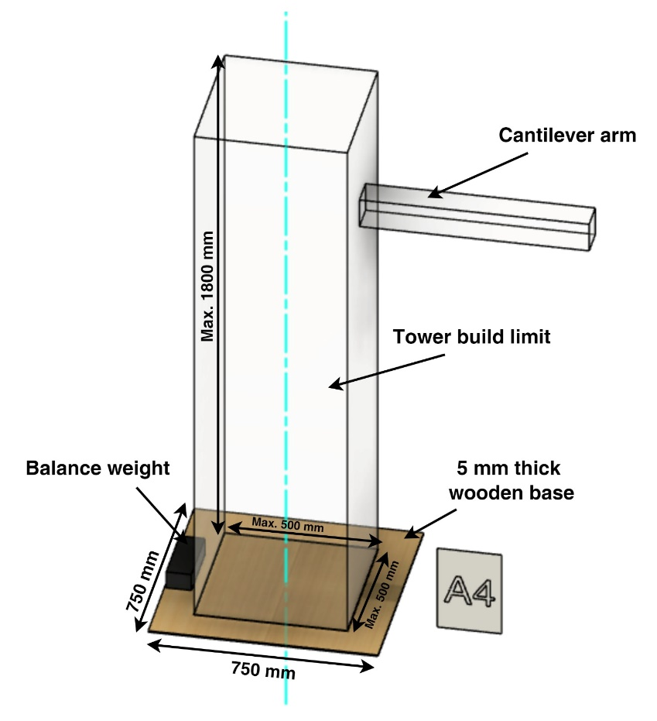

Figure 1: The configuration of the tower crane and the loading scheme.

**Rules**

1. If a team uses materials not provided by the organizer (or uses the provided tools as part of the model), the team will be disqualified.
2. Misconduct of any one of the team members will result in the disqualification of the whole team.
3. Team members need to move the model from the fabrication location to the loading area.
4. If there is any damage introduced on the model during the checking, transportation, and installation process, the team members will take the responsibility.
5. The teacher is not allowed to enter the fabrication area and communicate with students by electronic devices or other means during the competition.
6. Teams are not allowed to bring their trial models to the fabrication area.
7. Teams can bring their design drawings to the fabrication area.
8. Modification of the model after dimension check is not allowed.
9. Teams are not allowed to damage the baseboard.

**Materials for each team**

4 rolls of adhesive tape

**200** pieces of A4 paper (75 – 80 gsm)

Upon completion of the modelling, each team shall return ALL unused materials to a collection box.

Each team may bring along scissors, cutters, rulers and pens.

**Judging Criteria**

The competition is assessed by a judging panel to be assigned by the organizer. Judging panel shall comprise of engineers and academic staff.

1. **Height**

The height of cantilever arm is between 1.0m and 1.5m. It is measured from the top level of cantilever arm to the base of the tower. The total height of tower should not exceed 1.8m.

The height of tower crane will be measured and marks will be granted according to Table 1 and illustrated in Figure 3.

1. **Base length and width**

As illustrated in Figure 2, the base of the tower should not exceed the boundary comprised by 500mm x 500mm square. In case the base of the tower lies outside this boundary, the team will be DISQUALIFIED.

The length and width of the tower above the ground level would not be limited (except the dimension criteria in cantilever arm).

1. **Cantilever arm**

The length of the cantilever arm is taken as the distance from the centreline of the base to the point hanging the load as shown in Figure 3. The length of the cantilever arm is between 50cm and 100cm. If the length of cantilever arm is outside the range, it will be DISQUALIFIED. If the length of cantilever arm is longer than 60cm, marks will be granted according to table 1.

The headroom of the cantilever arm (which is measured from the lowest point of the cantilever arm to the base), as shown in Figure 3, shall provide at least 50cm. If the headroom is more than 60cm, points will be granted according to table 1.

1. **Loading**

During the loading test, member(s) from the team will add weight to hanger which is attached on the model. The loading point of the cantilever arm should be designed by students; each team is given a 25 mm long hook-and-loop fasteners (黏扣带) for the students to connect the end of their cantilever arm end to the hanger with loading. . In case the tower crane could not hang up any load by the fastener, the team will be DISQUALIFIED.

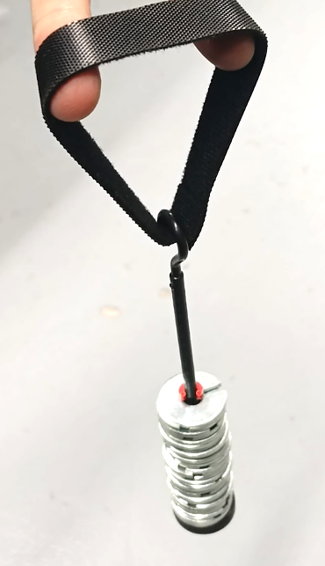

Figure 2 Fastener for hanger load

If the hanger of the structure touches the ground within 10 seconds after adding extra weight, it will be classified as a "failure". In such cases, the previous weight will be used for scoring, following the guidelines provided in Table 1. It is important to note that the maximum amount of weight that can be added to the structure is 800g.

1. **Lightness**

The assessment will involve weighing the model created by each team. The team with the lightest structure will receive 100 points for this part of the evaluation. Points will be assigned based on the criteria outlined in Table 1. Furthermore, the team that achieves the lightest model capable of supporting a minimum weight of 400g will be awarded the "Commendation on Lightest" distinction.

1. **Aesthetic and Innovative**

The tower will be assessed in terms of aesthetic and innovation. Each team should prepare a poster in A4 size to present their design idea. The poster could be prepared before the competition and it should be able to stand itself. The judging panel will rank the towers based on the poster, innovative structural form and aesthetic overall outlook. The team with the highest rank will get 50 points from this part of assessment. “Commendation on Aesthetic and Innovative” will be given to the team with the highest rank on aesthetic and innovation.

**Safety and Security**

During the competition, the organizer will take every possible precaution to ensure the safety of the participants and the spectators. However, participants and spectators shall be responsible for their own safety and personal properties.

**Adverse Weather Arrangements**

If a Pre-No. 8 typhoon warning signal (預告懸掛八號颱風訊號) or above remains hoisted at 7:00 a.m. on 19 July 2024, the competition will be postponed. The arrangements are also applicable when a black rainstorm warning signal is hoisted.

Please note that public announcements made by the Government's Education Department affecting primary and secondary schools, technical institutes and post-secondary colleges will also apply to the competition.

**Table 1 Scoring System**

|  |  |  |
| --- | --- | --- |
| Items | Criteria | Score |
| Height (from the top level of cantilever arm to the base of tower) | <1.0m | Disqualified |
| 1.0 - 1.1m (1.1m inclusive) | 20 |
| 1.1 - 1.2m (1.2m inclusive) | 40 |
| 1.2 - 1.3m (1.3m inclusive) | 60 |
| 1.3 - 1.4m (1.4m inclusive) | 80 |
| 1.4 - 1.5m (1.5m inclusive) | 100 |
| > 1.5 m | Disqualified |
| Total height of tower | >1.8 | Disqualified |
| Headroom of cantilever arm (from the lowest point of cantilever of tower crane) | < 50cm | Disqualified |
| 50 - 60cm (60cm inclusive) | 0 |
| 60 - 70cm (70cm inclusive) | 20 |
| 70 - 80cm (80cm inclusive) | 40 |
| 80 - 90cm (90cm inclusive) | 60 |
| 90cm - 100cm (100cm inclusive) | 80 |
| >100cm | 100 |
| Cantilever length | <50cm | Disqualified |
| 50 - 60cm (60cm inclusive) | 0 |
| 60 - 70cm (70cm inclusive) | 30 |
| 70 - 80cm (80cm inclusive) | 90 |
| 80 - 90cm (90cm inclusive) | 120 |
| 90 – 100cm (100cm inclusive) | 150 |
| >100cm | Disqualified |
| Loading |  | In case the tower crane could not hang up any weight above the ground, the team will be DISQUALIFIED. |
| 10 points per 10 g  (maximum loading: 800g) | 0 - 800 |
| Lightness | the lightest tower | 100 |
| the 2nd lightest tower | 90 |
| … | … |
| the 10th lightest tower | 10 |
| the 11st lightest tower and afterwards | 0 |
| Aesthetic and Innovation | the highest rank | 50 |
| the 2nd | 40 |
| … | … |
| the 5th | 10 |
| the 6th and afterwards | 0 |

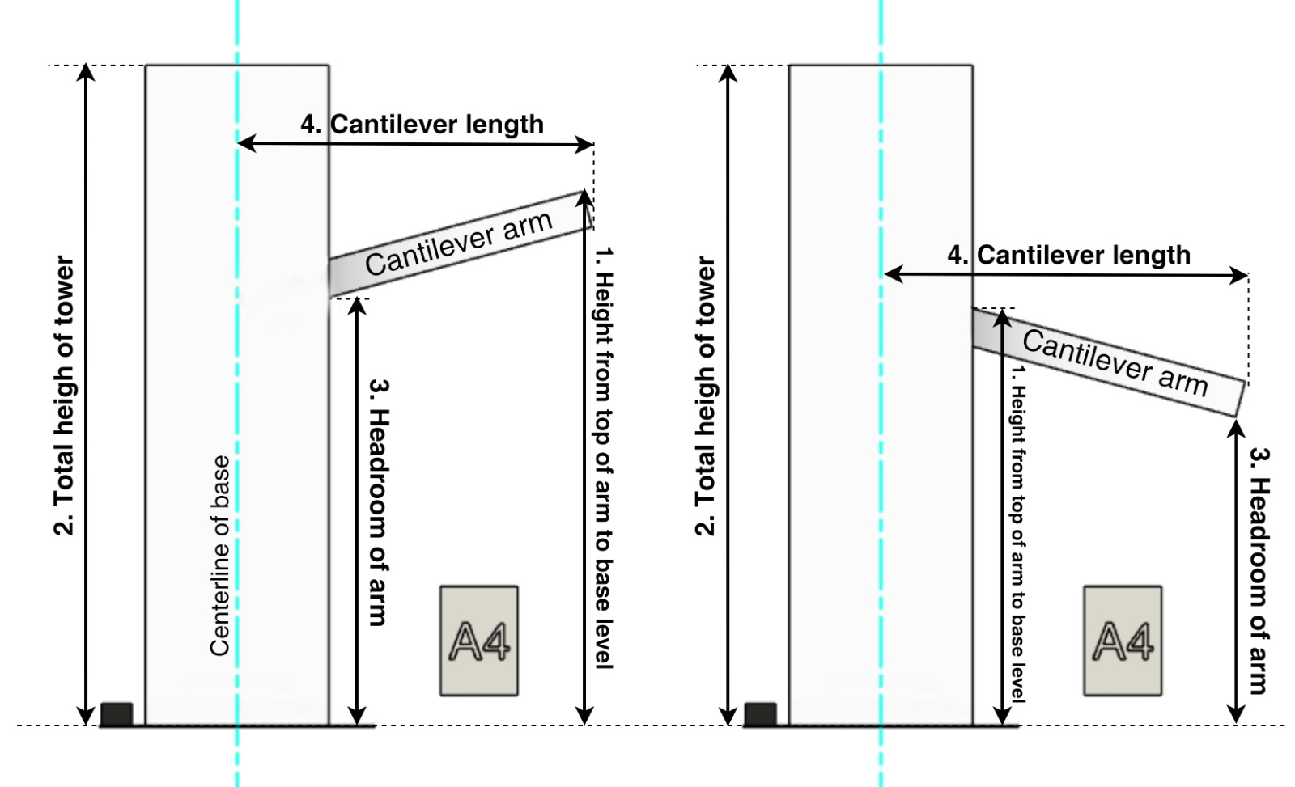

Figure 3 Measurement of total height, cantilever height, headroom and cantilever length

**Important Dates:**

Registration deadline: 25 June 2024 (Saturday)

Briefing: 5 July 2024 (Friday)

Venue: **Lecture Theatre 5,**

**Technological and Higher Education Institute of Hong Kong (THEi)**

**20A Tsing Yi Road, Tsing Yi**

Competition: 19 July 2024 (Friday)

Venue: **The Tam Wing Fan Innovation Wing, HKU**

**Certificates**

An attendance certificate will be issued for each participant.

**Prizes**

Prizes will be presented to the Champion ($3,000), First Runner-up ($2,000), Second Runner-up ($1,000)

Commendation on Lightest ($1,000)

Commendation on Aesthetic and Innovative ($1,000).

**Competition Schedule:**

|  |  |
| --- | --- |
| **Time** | **Program** |
| 8:45 am | **Registration** |
| 9:15 am | **Opening address** |
| 9:45 am | **Model fabrication** |
| 12:45pm | * + - 1. **Return and the unused materials**       2. **Submissions of Model**       3. **Height and weight measurement** |
| 1:00 pm | **Lunch**  **(Judging panel assesses the structure models)** |
| 2:30 pm | **Competition**  **Loading tests** |
| 4:30 pm | **Prize Presentation and Photos** |
| 5:00 pm | **End** |

**Notes**

1. The judging panel reserves the right to make the final decision and other interpretations.

2. For enquiry, please email to: ptcchkie@gmail.com